Before naything add necessary pages and menu items:
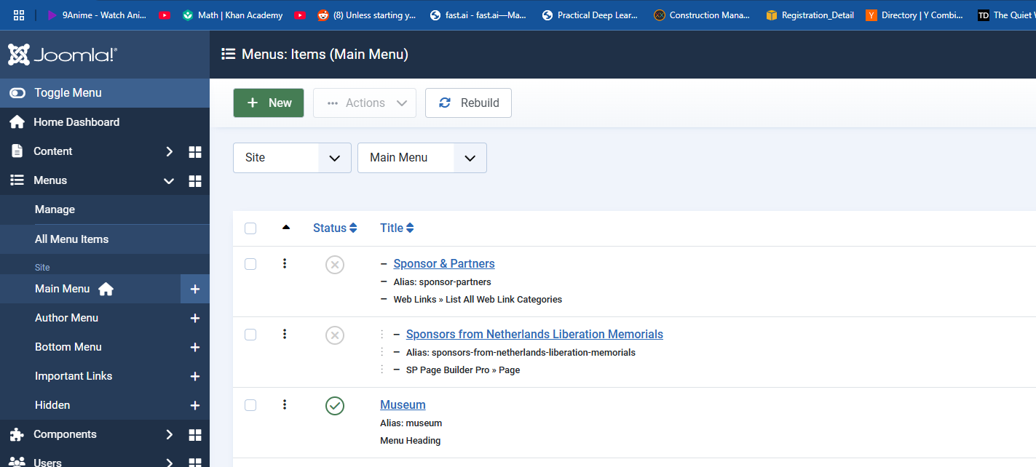

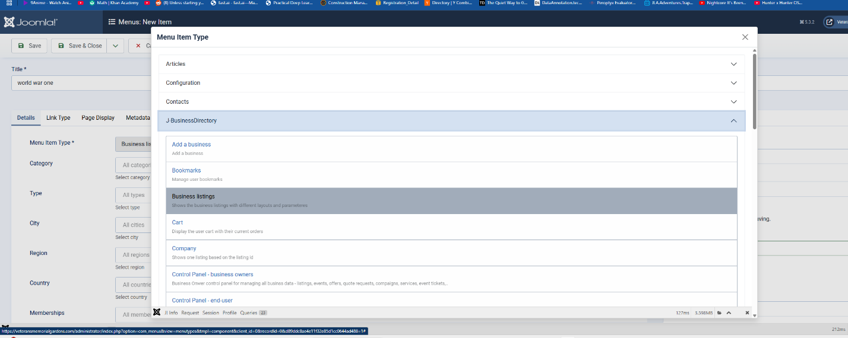

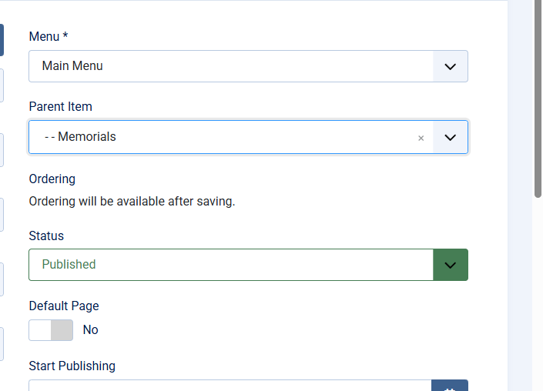Go to Menus → Main Menu
Click New
Fill out the fields like this:
- Menu Title: World War One
- Menu Item Type: Click Select
→ scroll to J-BusinessDirectory
→ choose Category Listings
- Choose Category: Select your world war one category from the dropdown
- Parent Item: Set this to Memorials (so it appears under Museum → Memorials)
  - If "Memorials" doesn't exist in your menu yet, create it first
Click Save & Close
Lastly save and close. I recommend saving the link just in case:
First add buisness listing.
In general info:
In name place name

with your combination of info find the best keywords.think of what future inquirers will use to find certain groups of people when considering keywords.
We will use a complete biography as our first example but note many soldiers are not complete in the sense of having all required paperwork. So do you best with what you have for each soldier.

Under media
Add his image as first image to see.
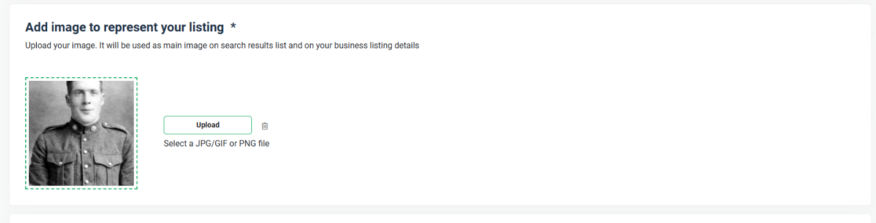
For category use world war one as that’s the war hew fought.
We then attach the necessary files:
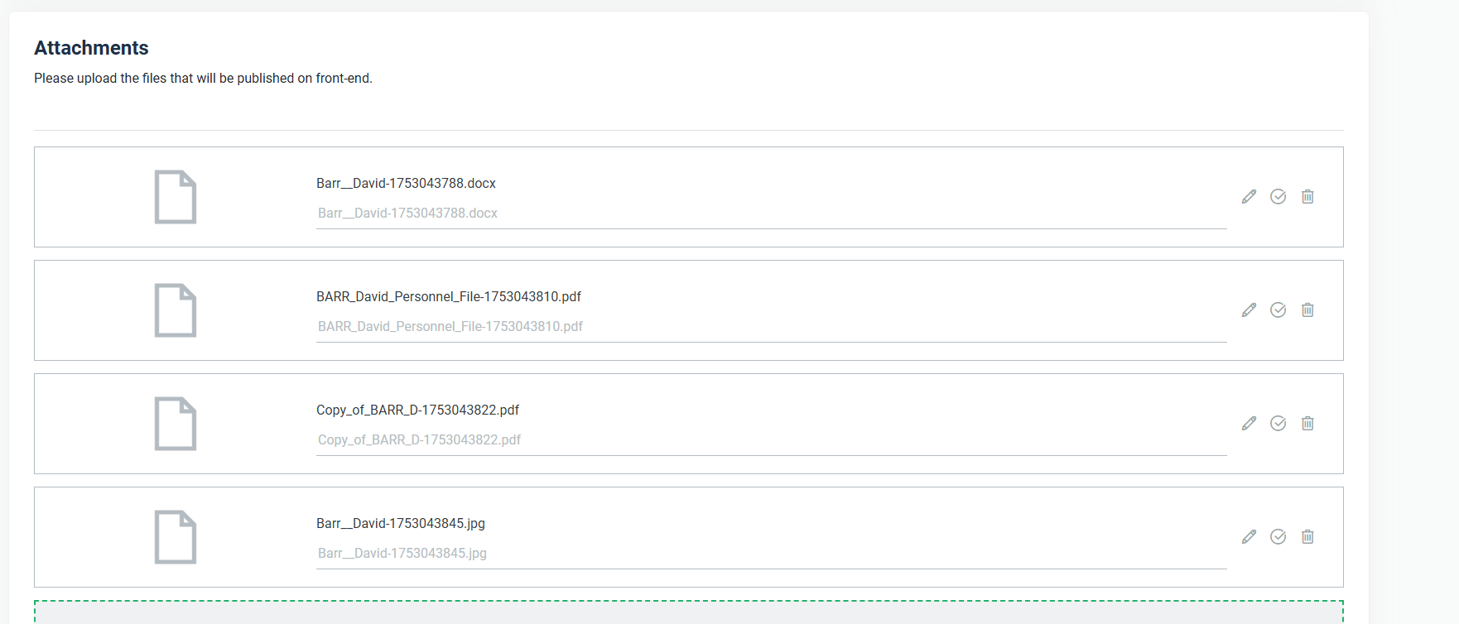

Save and close it.
Next approve it in listings:

